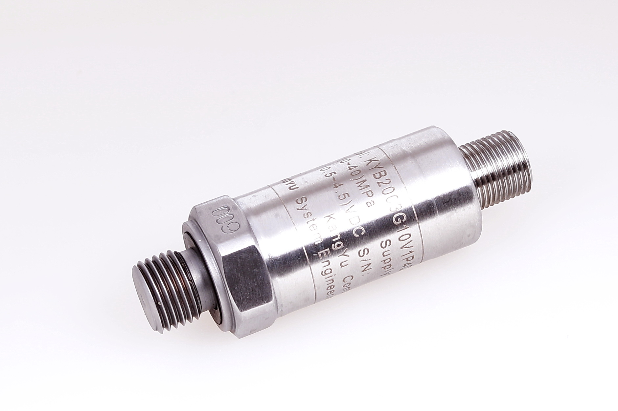
KYB2003H Pressure Transmitter
Description
KYB2003H is a new kind of sensor which introduces the foreign latest technology of MEMS. It has many advantages such as high overload resistance, impact resistance, good stability. This sensor is specially developed for pavement construction machinery in harsh environments and it is particularly suitable for measuring the high pressure of large hydraulic cylinder.

Application
Cranes, Excavators, Loaders, Boring machine, Rotary drilling rig, Pavers

Features
◆Wide measuring range, high measuring accuracy
◆Good long-term stability, high reliability
◆Excellent instantaneous overload resistance
◆Anti-interference ability, good moisture resistance
◆Rugged、easy to install
◆Can be customized according to the users requirements

Specifications
Product Type | Diffused silicon pressure transmitter
Media | Hydraulic oil、Gas、Various liquids compatible with 304 Stainless steel
Range | Any range within 0~70m
Supply Voltage | 10～30V/5V
Output | 4～20mA 、0.5～4.5V
Error in normal temperature | ±0.5%FS
Overload pressure | 3 X
Burst Pressure | 5 X
Ingress protection | IP65/IP67（Waterproof plug）
Electrical connection | Aviation connector, Hirschmann connector, or customized

Application Description
Torque detection of torque limiter is measuring the pressure of transformer oil of big and small cavity of automobile crane luffing cylinder through the pressure sensor, and converted into electrical signals，sent to central organization for calculation and display.

Ordering Information
KYB2003 |  | Pressure Transmitters
 |  | H | construction machinery dedicated
 |  |  | 代码 |  | Range |  |  |  |  |  |  |  |  | Error in normal temperature
 |  |  |  |  | Minimum measuring range |  |  |  |  | Maximum measuring range
 |  |  | 01 |  | 0～2MPa |  |  |  |  | 0～4MPa |  |  |  | ±0.5%
 |  |  | 02 |  | 0～5MPa |  |  |  |  | 0～7MPa |  |  |  | ±0.5%
 |  |  | 03 |  | 0～7MPa |  |  |  |  | 0～10MPa |  |  |  | ±0.5%
 |  |  | 04 |  | 0～10MPa |  |  |  |  | 0～20MPa |  |  |  | ±0.5%
 |  |  | 05 |  | 0～20MPa |  |  |  |  | 0～35MPa |  |  |  | ±0.5%
 |  |  | 06 |  | 0～35MPa |  |  |  |  | 0～60MPa |  |  |  | ±0.5%
 |  |  | 07 |  | 0～60MPa |  |  |  |  | 0～100MPa |  |  |  | ±0.5%
 |  |  |  |  | M1 |  | 4～20mA
 |  |  |  |  | V |  | 0～5V
 |  |  |  |  | V1 |  | 0.5～4.5V
 |  |  |  |  | VX |  | User defined
 |  |  |  |  |  |  | P2 |  | M20×1.5 external thread
 |  |  |  |  |  |  | P3 |  | NPT1/4 external thread
 |  |  |  |  |  |  | P4 |  | G1/4 external thread（Dedicated to more than 20 Mpa range）
 |  |  |  |  |  |  | Px |  | User defined（subject to conversion connector）
 |  |  |  |  |  |  |  |  | C1 |  |  | Aviation connector
 |  |  |  |  |  |  |  |  | C2 |  |  | Cable（Standard length 1M）
 |  |  |  |  |  |  |  |  | C3 |  |  | Hirschmann connector
 |  |  |  |  |  |  |  |  | CX |  |  | User defined
 |  |  |  |  |  |  |  |  |  |  |  | -I |  |  |  | New type（must choosen）
 |  |  |  |  |  |  |  |  |  |  |  |  |  |  |  | Calibration range by user
KYB2003 H |  |  | 01 | M1 |  | P2 |  |  |  |  | C2 |  | -I (0～1MPa)

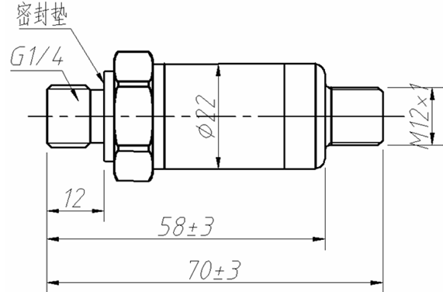
Dimension

Application Picture

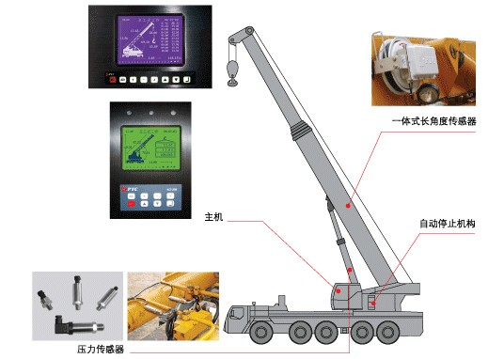
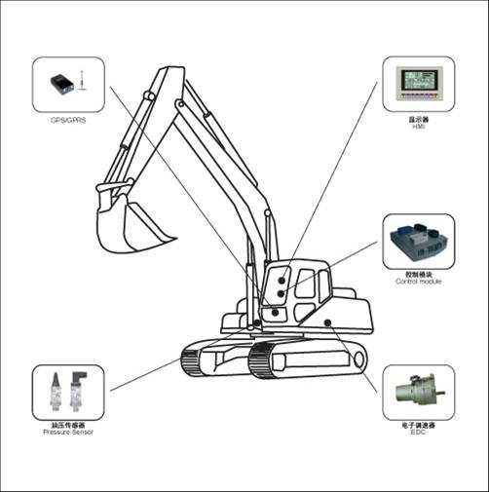

Gross weight：132g
Net weight：82g
Xinhui KangYu Control Systems Engineering, Inc.
Guifeng Hightech Village, Ximen Rd., Xinhui District, Jiangmen City, Guangdong 529100, P.R. China
Tel: 86-750-6318857 Fax: 86-750-6318900 E-mail: sale@chinakangyu.com Website: www.chinakangyu.com

