KYB14 Series Differential Pressure Transmitters

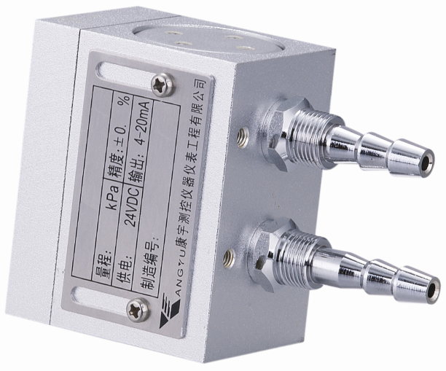
Description
KYB14 use famous brand high accuracy, high stability pressure sensor, the precision temperature compensation and amplification process converts the differential pressure signal measured medium into a standard signal output. High-quality sensors, superb packaging technology and improve the assembly process to ensure high quality and excellent performance.

Applications
Detection equipment supporting
Medical Devices supporting
Furnace pressure detection
Dust Removal in the field of environmental protection

Features
◆ High measurement accuracy
◆ High stability, high reliability
◆ Compact structure, easy to install
◆ Intrinsically safe, wide application
◆ Customized available

Application Description
The series has a variety of connectors and outlet options, with convenient installations, especially suitable for chamber pressure measurement, dust control and blower equipment and professional testing equipment and other supporting applications.

Structure A

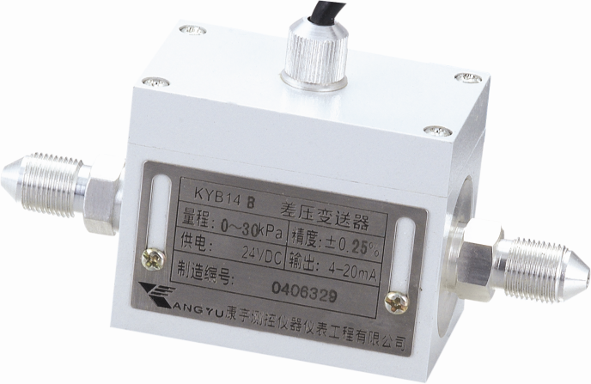

Structure B

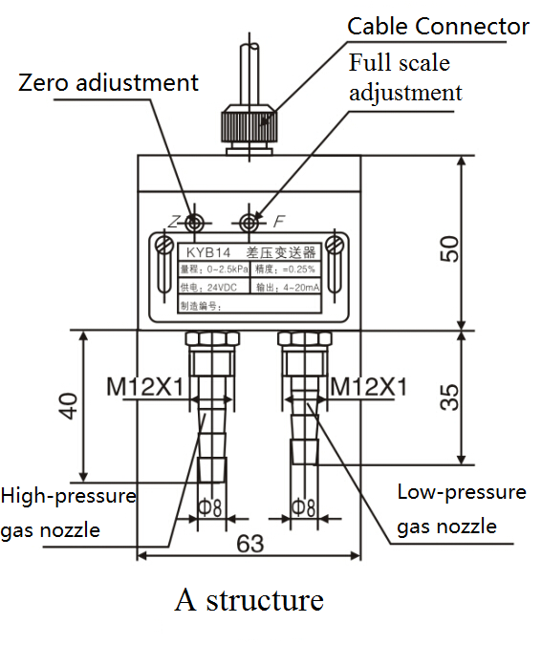
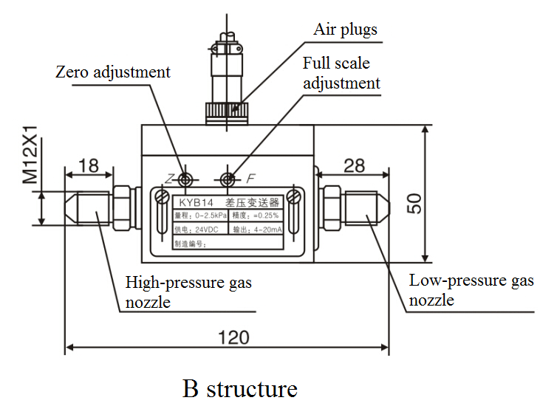
Dimension

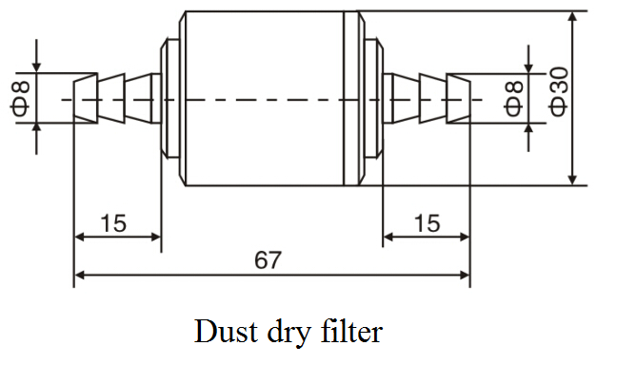

Specifications
Parameter | Value
Product Type | Diffused silicon pressure transmitter
Measure Media | Non-corrosive, non-dust, dry gas
Pressure Range | 0~250KPa (Minimum range：0~0.4KPa）
Output signal | 4～20mA(2-wire)，0～5VDC(3-wire)
Operating Voltage | 14～30VDC, Standard: 24VDC±5%, Ripple less than 1%
Medium Temperature | -10～70℃
Error in normal temperature | ±0.25%FS,±0.5%FS, ±1.0%FS
Error in working temperature range | ±1.5%FS(±0.25%FS in normal);±3.0% FS(±0.5%FS in normal);  ±5.0% FS(±1%FS in normal);
Error in time drift | ±0.25% FS/year（±0.25%FS in normal）;±0.5% FS/year（±0.5%FS in normal）; ±1% FS/year（±1%FS in normal）
Stability | ±0.25%FS/Y（0.25 grade）、±0.5%FS/Y（0.5 grade）、±1.0% FS/Y（1 grade）
Pressure Over-loaded | 2 X
Housing material | Aluminum
Explosion-proof mark | Intrinsically safe meet GB3836.1 GB3836.4 standards, mark: ExiaIICT5
※Note: If measure gas with dust or moisture, please make a special note when ordering, we have dust-dry filter available.

Ordering Information:
KYB14 |  | Differential pressure transmitter
 |  | A | Structure A
 |  | B | Structure B
 |  |  | Code |  | Range |  |  |  |  |  |  |  | Error in normal temperature
 |  |  |  |  | Minimum |  |  |  |  | Maximum
 |  |  | 01 |  | 0～0.4KPa |  |  |  |  | 0～1KPa |  |  |  | ±1%
 |  |  | 02 |  | 0～1KPa |  |  |  |  | 0～2.5KPa |  |  |  | ±0.5%
 |  |  | 03 |  | 0～2.5KPa |  |  |  |  | 0～7KPa |  |  |  | ±0.25%
 |  |  | 04 |  | 0～7KPa |  |  |  |  | 0～30KPa |  |  |  | ±0.25%
 |  |  | 05 |  | 0～30KPa |  |  |  |  | 0～100KPa |  |  |  | ±0.25%
 |  |  | 06 |  | 0～35MPa |  |  |  |  | 0～60MPa |  |  |  | ±0.25%
 |  |  |  |  | M1 |  | 4～20mA
 |  |  |  |  | V1 |  | 0～5V
 |  |  |  |  |  |  | P1 |  | M12x1 Thread
 |  |  |  |  |  |  | P7 |  | - Φ8 Gas nozzle (With M12×1 Mounting thread)
 |  |  |  |  |  |  | P8 |  | Quick Connector
 |  |  |  |  |  |  | PX |  | User defined
 |  |  |  |  |  |  |  |  | C1 |  |  | Air plugs
 |  |  |  |  |  |  |  |  | C2 |  |  | Cable（Standard length 1M）
 |  |  |  |  |  |  |  |  |  |  |  | i |  |  |  |  | Intrinsically Safe ExiaIICT5*
 |  |  |  |  |  |  |  |  |  |  |  |  |  |  |  |  | User calibration range
KYB14 A |  |  | 02 | M1 |  | P1 |  |  |  |  | C2 |  |  |  | i (0～2KPa)
* Intrinsically safe products only provide current output

Xinhui KangYu Control Systems Engineering, Inc.
Guifeng Hightech Village, Ximen Rd., Xinhui District, Jiangmen City, Guangdong 529100, P.R. China
Tel: 86-750-6318857 Fax: 86-750-6318900 E-mail: sale@chinakangyu.com Website: www.chinakangyu.com

