KYDM-F Series Magnetostrictive Transducers for Oil & Chemical
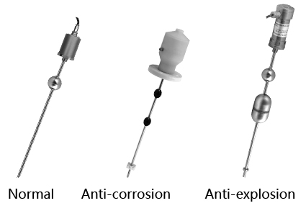
Product Type:
KYDM-F series anticorrosion magnetostrictive linear level transducer,
KYDM-F series flexible magnetostrictive linear level transducer,
KYDM-F series magnetostrictive linear level transducer, (hard tube)
(oil and chemical)

Description
KYDM magnetostrictive linear level transducer is a contactless
liquids level sensor designed for accurate absolute level measurement
of liquids. It can monitor the actual fluid level and temperature at the same time. Using excellent communication for monitoring and programming by EIA-RS485, data could be remote. The design and durability of the sensor make it ideal for measuring fluid levels of petroleum. The transducer provides analog output of voltage and current and digital output of Modbus. By utilizing the integral digital temperature sensor in probe, the fluid temperature could be measured as well as the level.

Applications:
Oil and chemical Scorch

Features:
◆High accuracy to meet the high requirements metering of tank level measurement occasions;
◆Stable performance, without affect of temperature and pressure changes of gas and liquid inside the tank;
◆Various output options to meet a variety of collection system requirements;
◆Intrinsic Safety Certification:ExiaIIBT5 to adapt to a variety of safe applications;
◆Modbus, which can measure various parameters of liquid level, interface, temperature;
◆Various anti-corrosive structure, to meet a wide range of oil, chlorine and other corrosive measurement environment;
◆Easy installation, no maintenance.

Specifications:
Measured position | Modbus—1~3 position or 1~5 temperature points  Analog—1~2 position
Operating voltage | +24VDC±10% ；±15VDC±10%
Outputs | 0～5VDC 0～10VDC -5～+5VDC  -10～+10VDC 4～20mADC ModBus Hart
Range | Rigid structure：50～5000mm  Flexible structure：4000~20000mm
Load characteristics | Current output:Load Resistance 600Ω(Max.)
Load characteristics | Voltage output:Load current 2mA(Max.)
Operating Current | ＜70mA
Operating temperature | -40～+85 ℃
Storage temperature | -40～+100 ℃
Non-linearity | ＜±0.01% F.S.or 1mm max.
Repeatability | ＜±0.002% F.S.
Resolution | 16bitD/A ,0.1mm
Hysteresis | ＜±0.002% F.S.
Temperature coefficient | ＜±0.007%F.S./℃
Zero range | 100%F.S.
full-scale range | 100%F.S.
Update time | depends on range,but less than 20ms
Probe material | A.0Cr18Ni9（304） B.316SS
Housing material | A.0Cr18Ni9(304)
Mounting | A.threaded connection B.threaded flange
Cable | integral cable, mating connector, integral connector
Sealing | Housing:IP65,Probe IP68
Explosion Proof | Exd ⅡBT5,Exia ⅡCT6
Note: The F.S. is short for Full Scale.

Application Overview:
KYDM Magnetostrictive liquid level transducer (Oil Chemical dedicated) provides high accurate measurement of liquids level sensor designed for huge tank or vessels. It can be tailored to special length and mounting requirements for petrochemical applications. It transmits and monitors level, interface, and temperature at the same time. In addition, volume, density and weight can be work out.

Ordering Information:
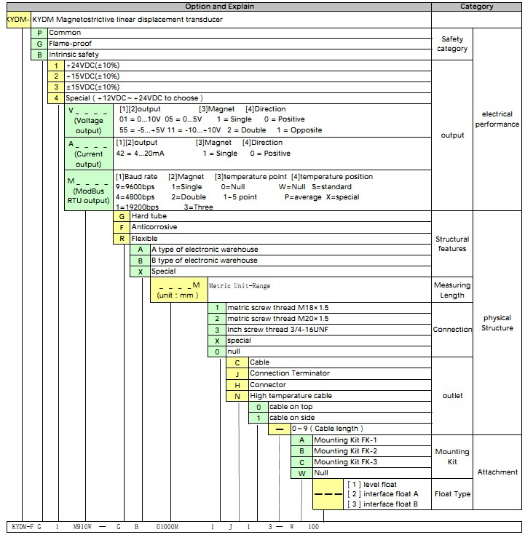

For example: KYDM-FG1M910W-GB01000M1J13-W100
Notes: 1. Pls. specify product model number for correct order.
2. Just for level transducer.

Product Dimension:
ion：
Anticorrosive
flange
Anticorrosive
shell
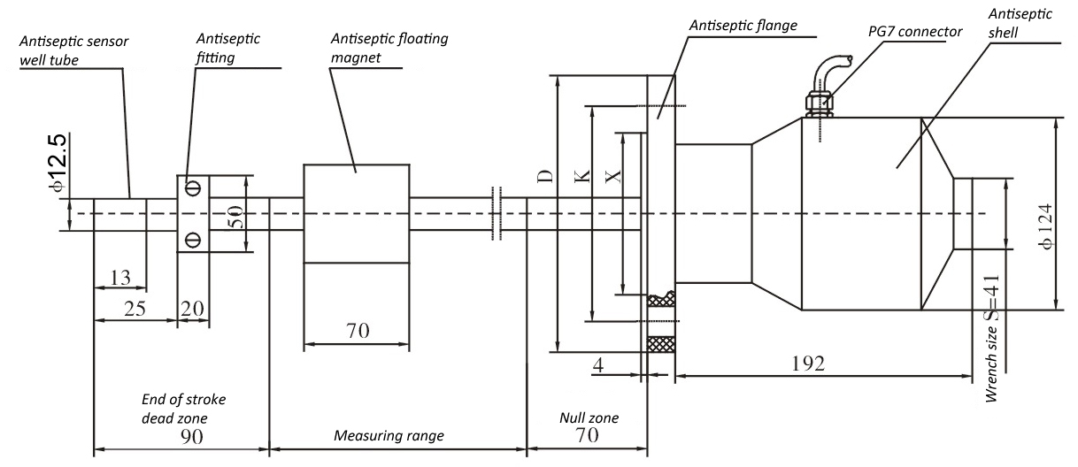
Anticorrosive
fitting
Anticorrosive
float

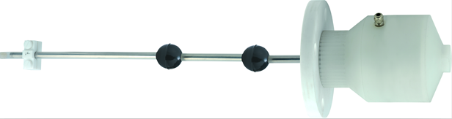

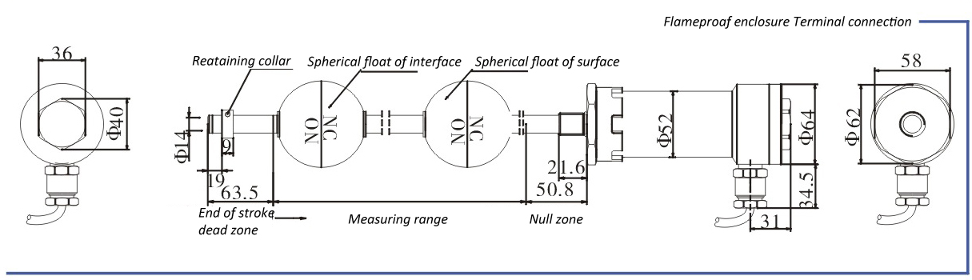
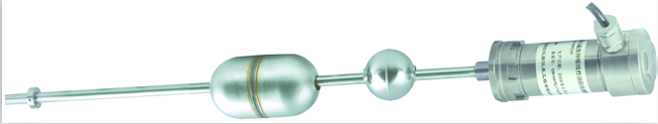

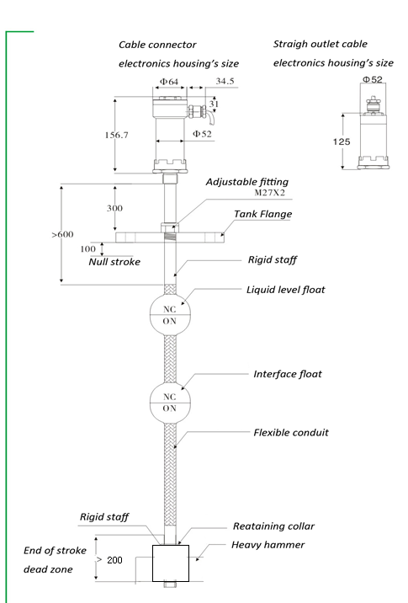

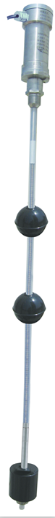

Hard tube

Hard tube

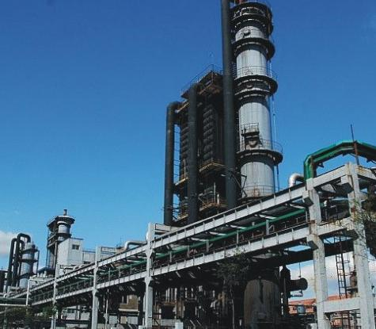
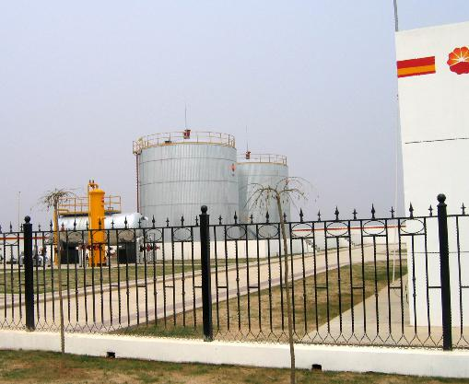


Xinhui KangYu Control Systems Engineering, Inc.
Guifeng Hightech Village, Ximen Rd., Xinhui District, Jiangmen City, Guangdong 529100, P.R. China
Tel: 86-750-6318857 Fax: 86-750-6318900 E-mail: sale@chinakangyu.com Website: www.chinakangyu.com

