KYDM-F for Mobile Base Stations
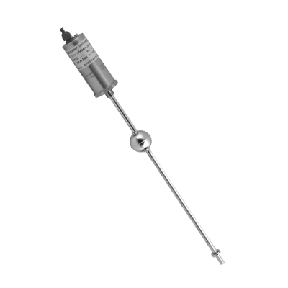
Description
Utilizing magnetostrictive technology, the magnetostrictive linear displacement transducer measures the distance from a predetermined point (Zero point) to the magnetic field produced by a movable permanent magnet. As the moving magnet’s position is coupled by the magnetic field, the magnetostrictive linear displacement transducer requires no mechanical contact between parts that would cause friction and wear. The magnetostrictive linear displacement transducer provides an absolute output, therefore, no data is lost if power is interrupted. The magnetostrictive linear displacement transducer offers modular construction, flexible mounting configurations and easy installation.

Application：
Level detection for Mobile Base Stations

Features
◆ High stability and accuracy of 0.1% FS, fully meet customer 1 ~ 2mm accuracy requirements;
◆ Match with the system instantly reflect the changes in the fuel tank level to address the needs of the customer point of greatest concern;
◆ can instantly make a control scheme based on customer requirements for the dead zone, the tracking service win customers’ recognition;
◆ Easy for installation. Holing based on the flange specified size, fix the sensor with the flange cover on the tank when the tank is working;
◆ With adjustable device for different specifications of the tank, can be up and down to fine-tune, standardized product range.

Specifications:
Measured position | 1position
Outputs | 4-20mA，ModBus
Measuring range | 300~2000mm
Operating voltage | 12VDC±10%
Non-linearity | ＜±0.05% F.S.or 100um max.
Repeatability | ＜±0.002% F.S.
Resolution | 16bitD/A , 1um
Temperature coefficient | ＜±0.02%F.S./℃
Operating temperature | -20～+80 ℃
Storage temperature | -40～+100 ℃
Sealing | IP65
Operating Current | ＜70mA
Zero range | 100%F.S.
full-scale range | 100%F.S.
Update time | depends on range,but less than 20ms
Probe material | A.0Cr18Ni9（304） B.316SS
Housing material | A.0Cr18Ni9(304)
Mounting | A.threaded connection B.threaded flange
Cable | integral cable, mating connector, integral connector
Sealing | Housing:IP65,Probe IP68

Application Overview:
KYDM series of magnetostrictive linear displacement transducer using non-contact magnetostrictive principle, with durability, and widely be used in the Mobile Base Stations.

Ordering Information：
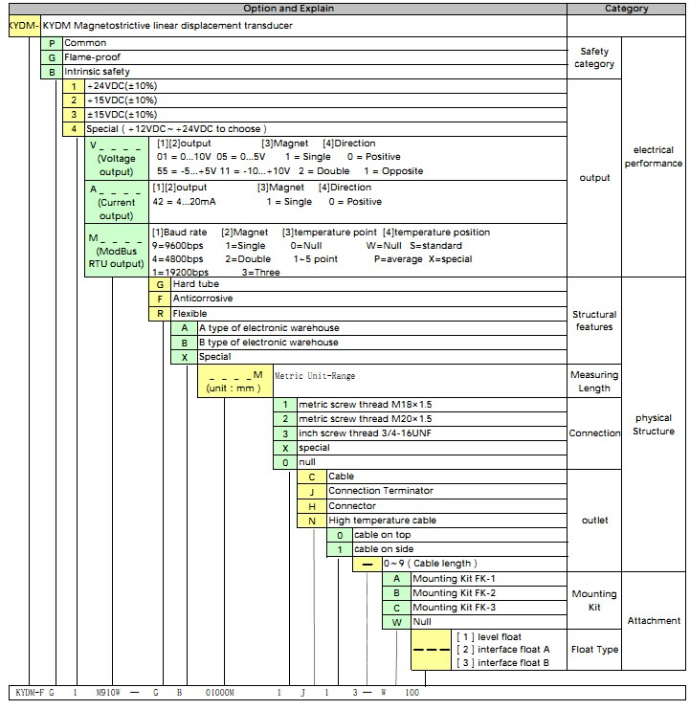

Order Sample: KYDM-FG1M910W-GB01000M1J13-W100

Product Dimension：

Packaging size：Φ7.5cm*L（L=range+450mm，integral cable）
Φ7.5cm*L（L=range+300mm，mating connector）

GW：1kg
Net weight：0.9kg
Xinhui KangYu Control Systems Engineering, Inc.
Guifeng Hightech Village, Ximen Rd., Xinhui District, Jiangmen City, Guangdong 529100, P.R. China
Tel: 86-750-6318857 Fax: 86-750-6318900 E-mail: sale@chinakangyu.com Website: www.chinakangyu.com

