KYDM-LF Series Magnetostrictive Linear Displacement Sensors
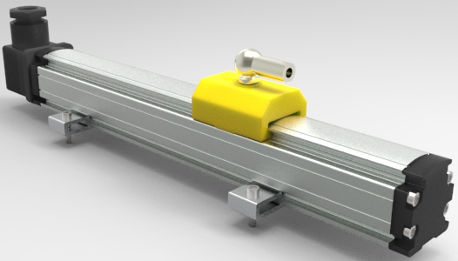
Description
KYDM-LF series Magnetostrictive Linear
Displacement Sensor (short for KYDM-LF)
is a contactless linear position sensor providing
high accurate absolute position measurement of
displacements. Contactless sensing with highest
durability, the extremely robust sensor, ideal for
continuous operation under harshest industrial
conditions is completely modular in mechanic and electronic design. Absolute output, no periodic re-calibration and maintenance, no need to re-zero. KYDM series of Magnetostrictive Linear-Displacement Sensor can support variety of signal outputs as voltage，current，pulse，SSI，ModBus，Profibus bus, and supports single sensor measuring two coaxial position. Magnetostrictive linear displacement sensor can completely replace electronic device or encoder used in injection molding machines moving parts, injection, ejection precise positioning.

Applications
Injection molding machine
Ceramic press machine
Extrusion machine
Hydraulic press

Features
Contactless Sensing with Highest Durability;
Double encapsulation ensures high operating safety and optimum EMC protection;
Absolute output, no periodic re-calibration and maintenance, no need to re-zero;
Easy installation, no maintenance.

Specifications
Measuring range | 80~3000mm
Operating voltage | +24VDC±10%
Outputs | 0～5VDC 0～10VDC 4～20mADC SSI
Non-linearity | ＜±0.05% F.S. or 100um max.
Repeatability | ＜±0.002% F.S.
Resolution | 16bitD/A , 1um
Temperature coefficient | ＜±0.007%F.S./℃
Load characteristics | Current output: Load Resistance 500Ω(Max.)
Load characteristics | Voltage output: Load current 2mA(Max.)
Operating temperature | -40～+85 ℃
Storage temperature | -40～+100 ℃
Sealing | IP65
Note: The F.S. is short for Full Scale.
Application Overview:
KYDM series Magnetostrictive Linear-Displacement Sensor using non-contact magnetostrictive principle, with durability, and can be used in the injection molding machine mold, injection, transfer seat, the top of the displacement stroke detection.

Ordering Information:
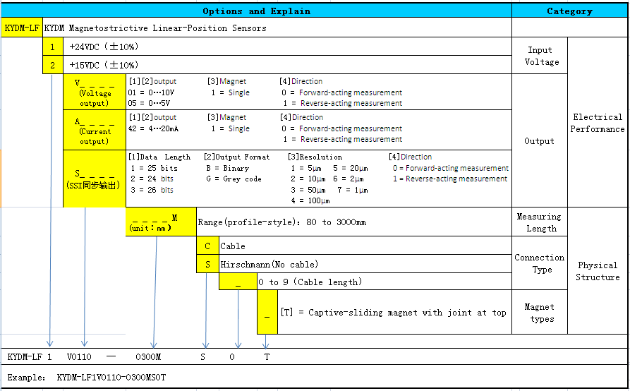

Product Diagram:
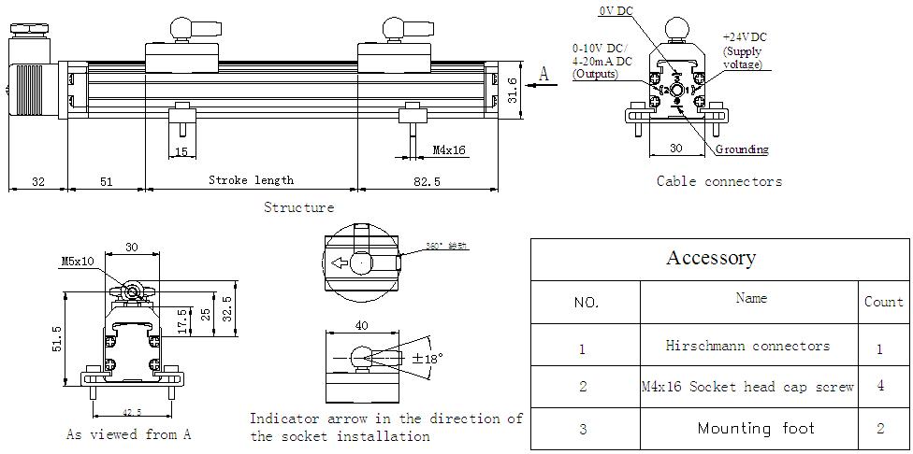

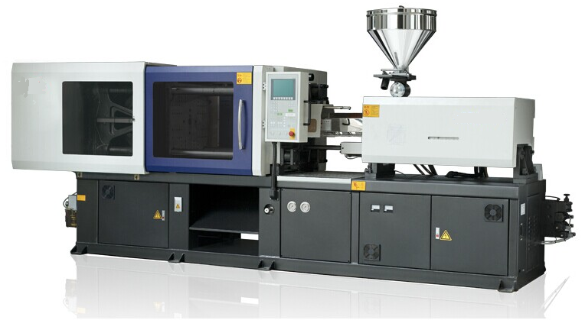
Application Picture:
Xinhui KangYu Control Systems Engineering, Inc.
Guifeng Hightech Village, Ximen Rd., Xinhui District, Jiangmen City, Guangdong 529100, P.R. China
Tel: 86-750-6318857 Fax: 86-750-6318900 E-mail: sale@chinakangyu.com Website: www.chinakangyu.com

